Inscribe
# Source: AI Source: Provided by: [Data Path: Persons Table -> ID Column: 1, Name_En Column: Motasem Essam] -> From: [ChatGPT] on [7/25/2026]
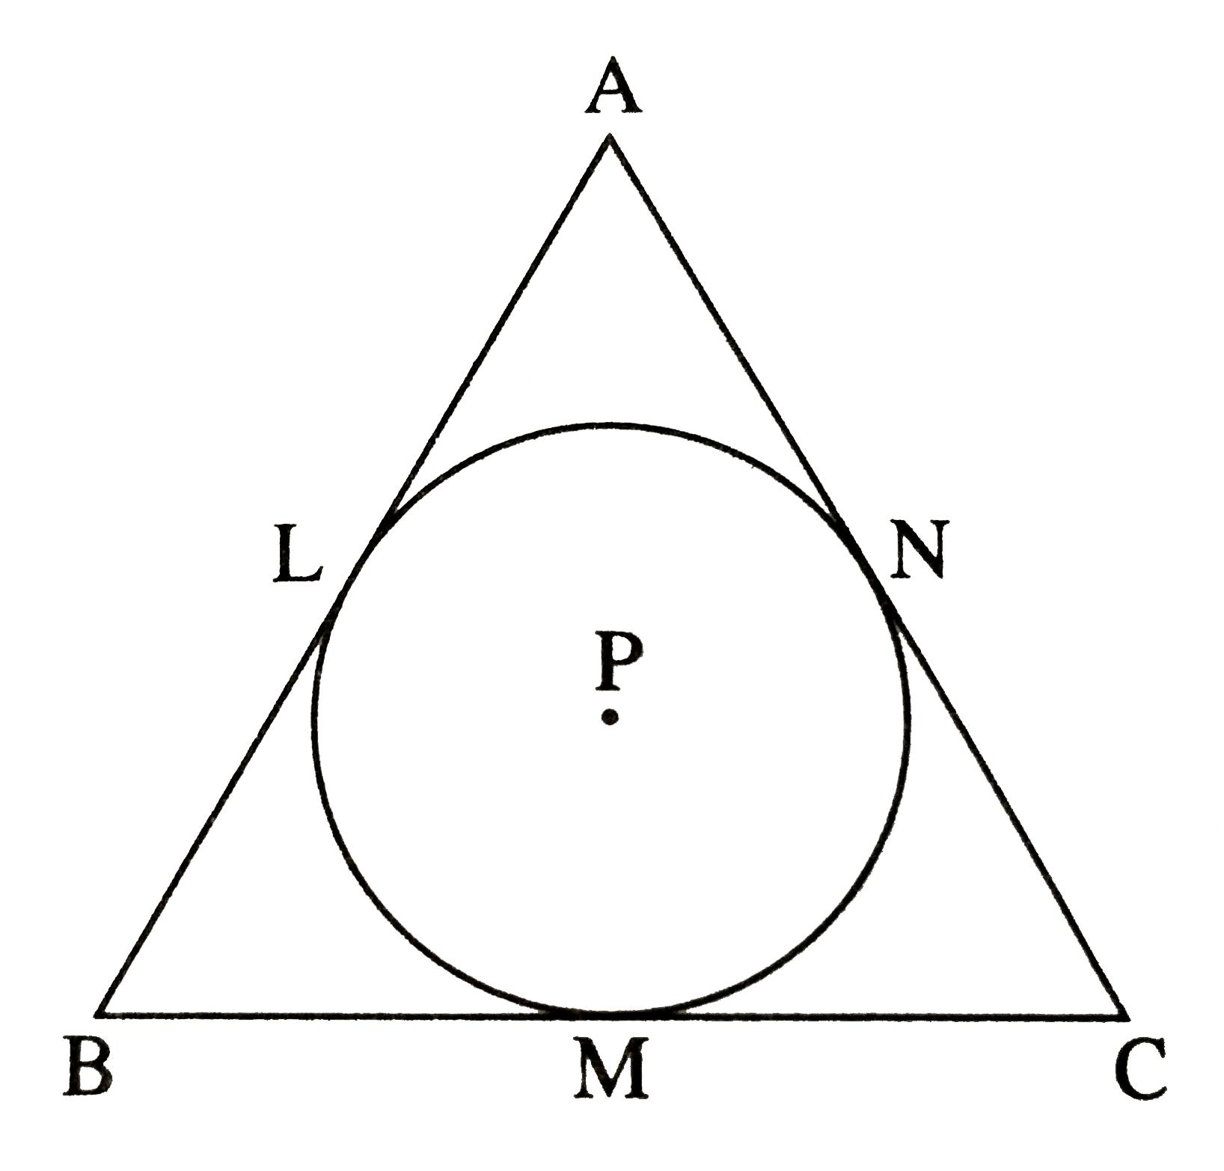
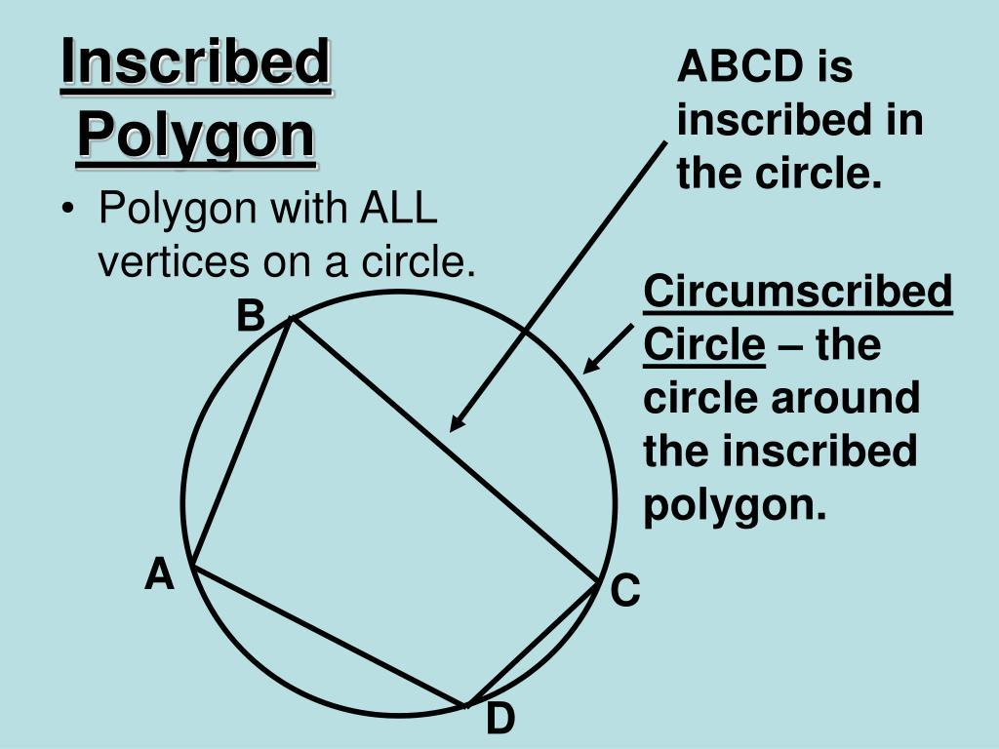
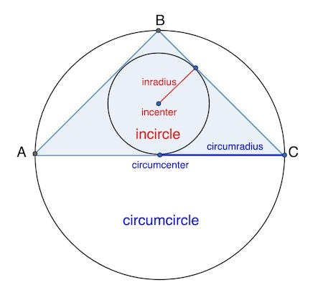
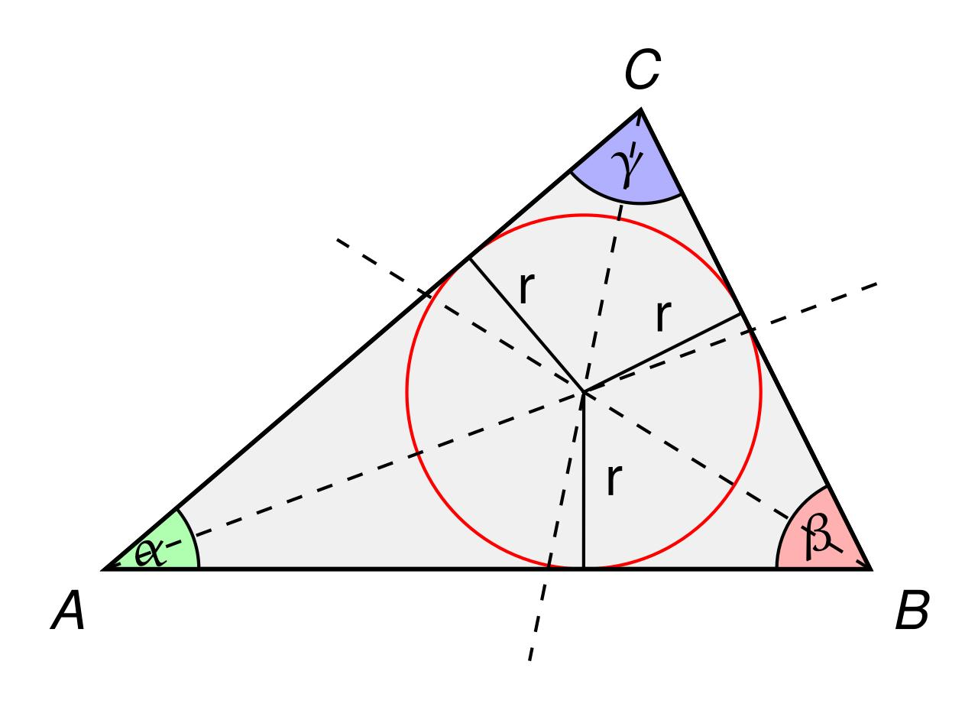
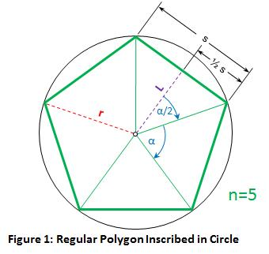
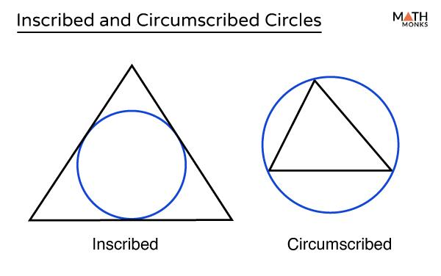

Definition
# Source: AI Source: Provided by: [Data Path: Persons Table -> ID Column: 1, Name_En Column: Motasem Essam] -> From: [ChatGPT] on [7/25/2026]
To inscribe one geometric object in another means to place the first object inside the second so that it satisfies a specific boundary condition, usually by touching the boundary.
In particular:
- A circle is inscribed in a polygon when the circle lies inside the polygon and is tangent to its sides.
- A polygon is inscribed in a circle when all of its vertices lie on the circle.

Main Types
# Source: AI Source: Provided by: [Data Path: Persons Table -> ID Column: 1, Name_En Column: Motasem Essam] -> From: [ChatGPT] on [7/25/2026]
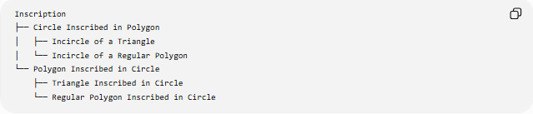
Inscription
├── Circle Inscribed in Polygon
│ ├── Incircle of a Triangle
│ └── Incircle of a Regular Polygon
└── Polygon Inscribed in Circle
├── Triangle Inscribed in Circle
└── Regular Polygon Inscribed in Circle

Circle Inscribed in a Polygon
# Source: AI Source: Provided by: [Data Path: Persons Table -> ID Column: 1, Name_En Column: Motasem Essam] -> From: [ChatGPT] on [7/25/2026]
The circle is inside the polygon and touches the polygon's sides.
For a triangle:
$$\text{Incircle}⊂△ABC$$
The center of the incircle is the incenter, and its radius is the inradius.

Polygon Inscribed in a Circle
# Source: AI Source: Provided by: [Data Path: Persons Table -> ID Column: 1, Name_En Column: Motasem Essam] -> From: [ChatGPT] on [7/25/2026]
The polygon is inside the circle, with every vertex lying on the circle.
For a triangle:
$$A,B,C∈\text{Circle}$$
The circle passing through the vertices is the circumcircle, and its radius is the circumradius.
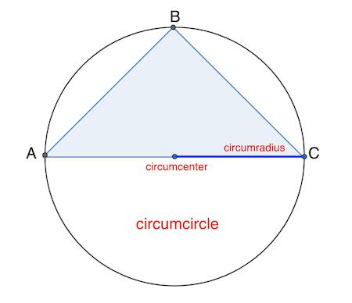
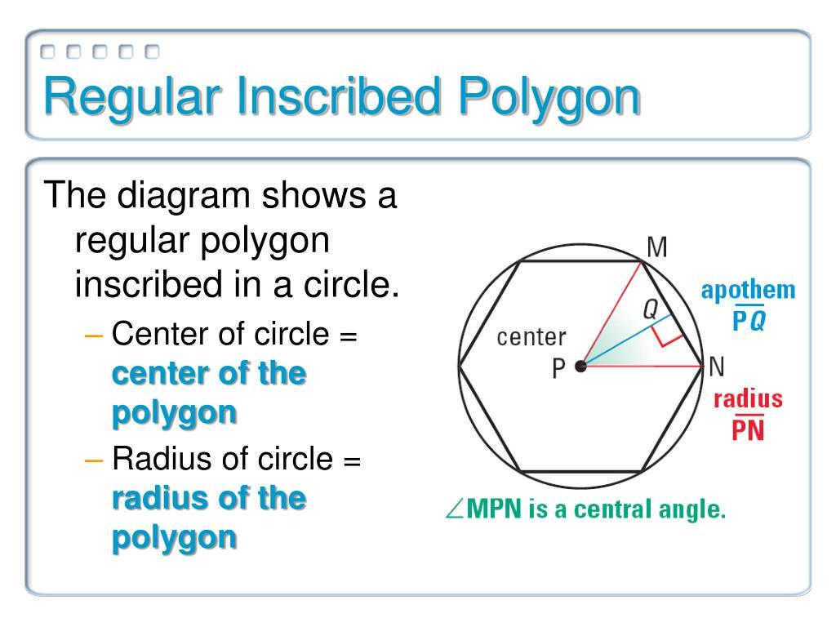
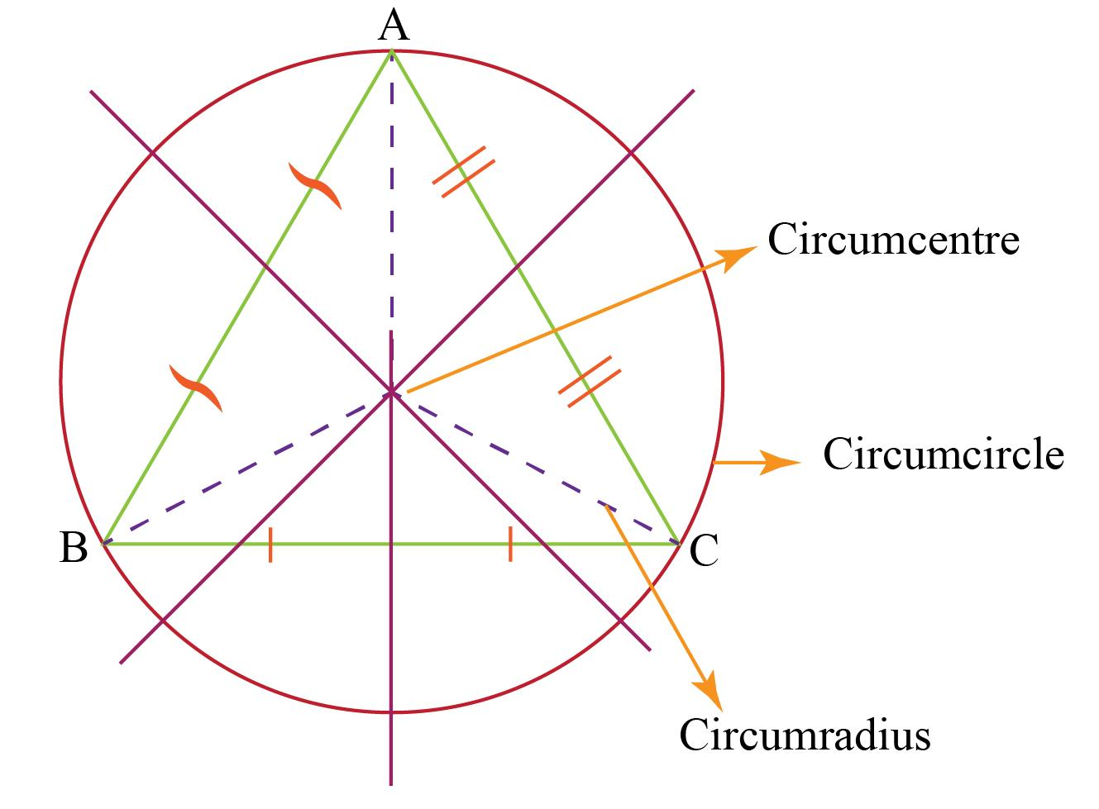
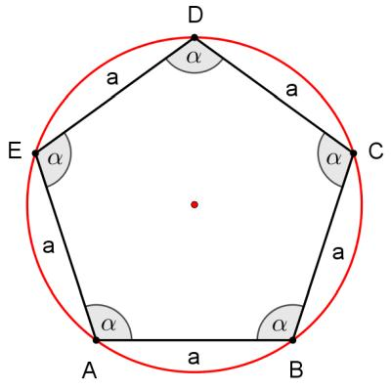

Inscribe vs Circumscribe
# Source: AI Source: Provided by: [Data Path: Persons Table -> ID Column: 1, Name_En Column: Motasem Essam] -> From: [ChatGPT] on [7/25/2026]
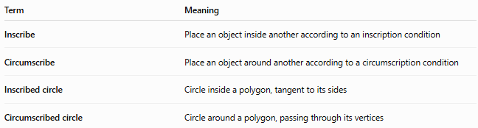
Term | Meaning
Inscribe | Place an object inside another according to an inscription condition
Circumscribe | Place an object around another according to a circumscription condition
Inscribed circle | Circle inside a polygon, tangent to its sides
Circumscribed circle | Circle around a polygon, passing through its vertices

Example
# Source: AI Source: Provided by: [Data Path: Persons Table -> ID Column: 1, Name_En Column: Motasem Essam] -> From: [ChatGPT] on [7/25/2026]
A circle tangent to all three sides of a triangle is inscribed in the triangle.
The triangle is therefore circumscribed about the circle.

Related Terms
# Source: AI Source: Provided by: [Data Path: Persons Table -> ID Column: 1, Name_En Column: Motasem Essam] -> From: [ChatGPT] on [7/25/2026]
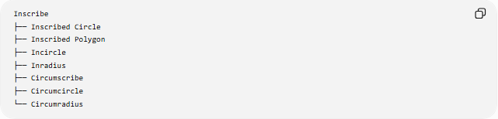
Inscribe
├── Inscribed Circle
├── Inscribed Polygon
├── Incircle
├── Inradius
├── Circumscribe
├── Circumcircle
└── Circumradius
Key distinction: inscribe describes the relationship or action; inradius is a measurement—the radius of an inscribed circle.

